

The personalised care and support planning practice checklist

Getting started with personalised care and support planning (PCSP)
This personalised care and support planning practice checklist has been developed to support practices new to personalised care and support planning.

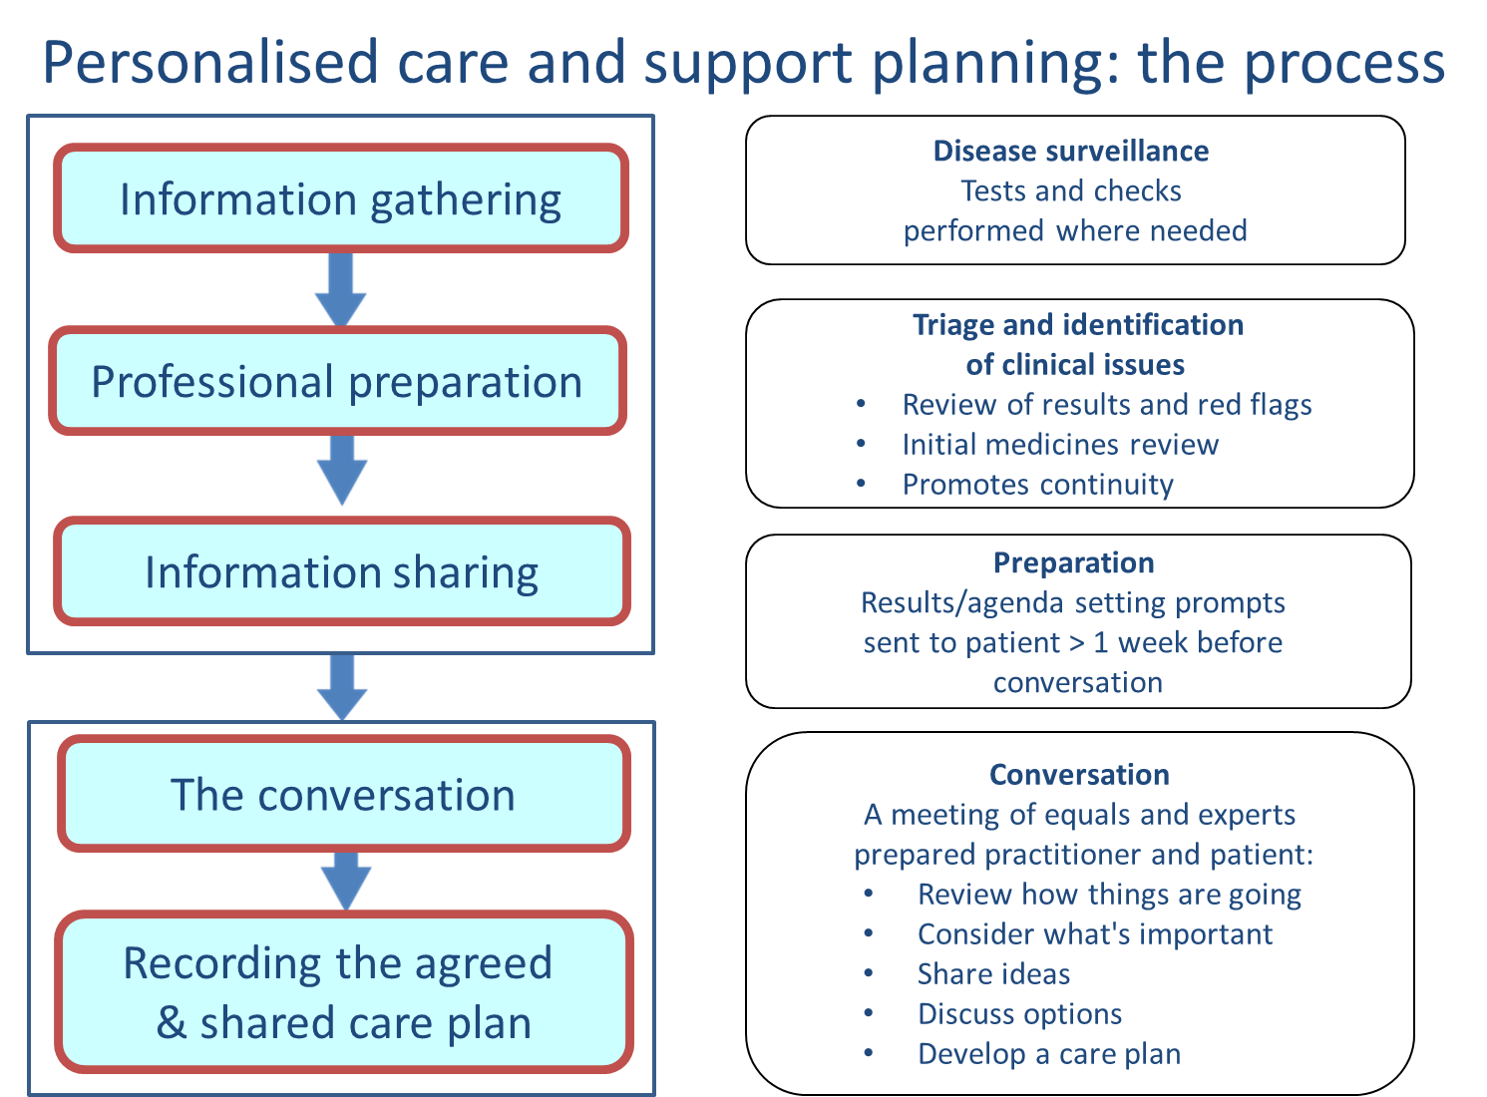

The checklist is based on the experiences of other teams. It can be used by a practice team to identify what is needed at each of the key steps in the personalised care and support planning process.

This resource will allow you to map how your team is doing and identify ‘next steps’ as it guides you through the personalised care and support planning process as a checklist.

It will help you to cross-check what is important to have in place and signpost you to some resources that are available.

Personalised care and support planning requires a whole team approach which involves changing systems and changing the nature of conversations between practitioners and people with long-term conditions. We strongly recommend that the practice forms a small steering group who meet regularly to review progress with personalised care and support planning.
The personalised care and support planning practice checklist

What have you got? |  | Which one applies best?
Anchor points (roughly in chronological order) |  | We have cracked it | We are nearly there | We have good ideas | What are the next steps for us? | Where can we get more help with this?
Set up and initial organisation | There is a local practice steering group to implement and troubleshoot with a clinical and admin lead |  |  |  |  | Section 1  Getting started with PCSP  Section 2 Materials to promote PCSP  Section 3 Recall and appts  Section 4  Info gathering appt
Set up and initial organisation | We have identified the group of patients that we will initially commence PCSP with
Set up and initial organisation | We set up a robust register and recall system in place for these patients with long-term condition(s)
Set up and initial organisation | We have decided what we are calling the new way of working and all staff can describe how it works and what the benefits are
Set up and initial organisation | We have decided who will be involved at each step of the process  - Information gathering appointment  - Triage of results  - PCSP appointment/conversations  - Who/how doing admin
Set up and initial organisation | We have a process to arrange both appointments
Set up and initial organisation | We have decided how long the PCSP conversations will be with different groups of patients
Set up and initial organisation | We have room/capacity to accommodate appointments
Set up and initial organisation | We have decided how we are going to inform people about the changes to their annual reviews

What have you got? |  | Which one applies best?
Anchor points (roughly in chronological order) |  | We have cracked it | We are nearly there | We have good ideas | What are the next steps for us? | Where can we get more help with this?
Information gathering appointment | Our reception staff are clear about the new appointment system |  |  |  |  | Section 2 Materials to promote PCSP  Section 3 Recall and appt  Section 4 Information gathering appt  Section 5  Triage – ‘professional preparation’
Information gathering appointment | We have an information leaflet explaining the changes and have created invitation letters for appointments
Information gathering appointment | We have an information gathering template which guides completion of clinical tests into a long-term conditions template (in our medical records) and a decision about who will enter this data
Information gathering appointment | We have developed agreed protocols of any immediate issues that need to be flagged  (Protocols might include parameters for which the tester would seek advice such as very high blood pressure, suicidal thoughts, haematuria)
Information gathering appointment | We have identified a means of providing additional training and supervision for the HCA if taking on new roles

What have you got? |  | Which one applies best?
Anchor points (roughly in chronological order) |  | We have cracked it | We are nearly there | We have good ideas | What are the next steps for us? | Where can we get more help with this?
Professional preparation  (Triage) | We have a mechanism to handle results from the laboratory which links the results to the personalised care and support planning process |  |  |  |  | Section 5  Triage – ‘professional preparation’  Section 6 Patient preparation
Professional preparation  (Triage) | We have an identified member of staff to review all of the information gathered and handle urgent issues (red flags)
Professional preparation  (Triage) | We have a mechanism for the administrative team to be prompted to populate and send preparation material to the patients before their personalised care and support planning appointment
Professional preparation  (Triage) | We have considered how triage can be used to support the personalised care and support planning conversations/appointments e.g. supporting staff development, identifying prescribing issues

What have you got? |  | Which one applies best?
Anchor points (roughly in chronological order) |  | We have cracked it | We are nearly there | We have good ideas | What are the next steps for us? | Where can we get more help with this?
Information sharing between appointments | We have a system for sending preparation prompts 1-2 weeks before their personalised care and support planning appointment |  |  |  |  | Section 4 Information gathering appointments  Section 6 Patient preparation  Section 7  Frailty in the community (proactive care)
Information sharing between appointments | We have a range of preparation prompts for patients across a range of conditions which include an agenda setting sheet and routine results for the conditions people live with
Information sharing between appointments | We have an accompanying explanatory document so that people can understand their results
Information sharing between appointments | We know who will administer this process and send the preparation prompts to patients (results letter/agenda-setting sheet)
Information sharing between appointments | We have a system for people to make their PCSP consultation/appointment and identify their preference around this being remote or face to face

What have you got? |  | Which one applies best?
Anchor points (roughly in chronological order) |  | We have cracked it | We are nearly there | We have good ideas | What are the next steps for us? | Where can we get more help with this?
Consultation and joint decision-making with a ‘prepared HCP’. To produce an agreed and shared care plan. | We have accessible results prior to consultation |  |  |  |  | Section 1  Getting started with PCSP  Section 8  The PCSP conversation  Section 9 Recording the care plan
 | We have a system that facilitates the recording of an agreed and shared care plan
We have a template for the agreed care plan (to summarise consultation)
- A system to record the care plan in the clinical record
- A method of providing the patient with a copy
 | We have a protected appointment that allows time for a meaningful consultation
 | We have a menu of local resources and support available in our area and a mechanism to link people, to local community activities and support for self-management

What have you got? |  | Which one applies best?
Anchor points (roughly in chronological order) |  | We have cracked it | We are nearly there | We have good ideas | What are the next steps for us? | Where can we get more help with this?
Personalised care and support planning competencies and skills | For each individual clinician
 | I am comfortable with my ‘gather & share stories’ skills |  |  |  |  | Section 8 The PCSP conversation  Section 10  Evaluation of PCSP
 | I am comfortable with my ‘explore & discuss’ skills
 | I am comfortable with my ‘goal setting and action planning’ skills
 | We’ve had a bit of a go and had the chance to reflect on my skills
 | How are we doing overall?

