**NHS Col**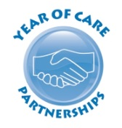

**My yearly check up**

**How can it help me?**

Thanks to the staff at Bridges Medical Practice and to the Gateshead People Self Advocacy group for their invaluable help in the making of this leaflet.

**What is my yearly check-up?**

It is a new way of working with people with long-term health conditions.

Along-term condition is a health problem that is always there but can be treated.

Diabetes, breathing problems and heart disease are long-term conditions.

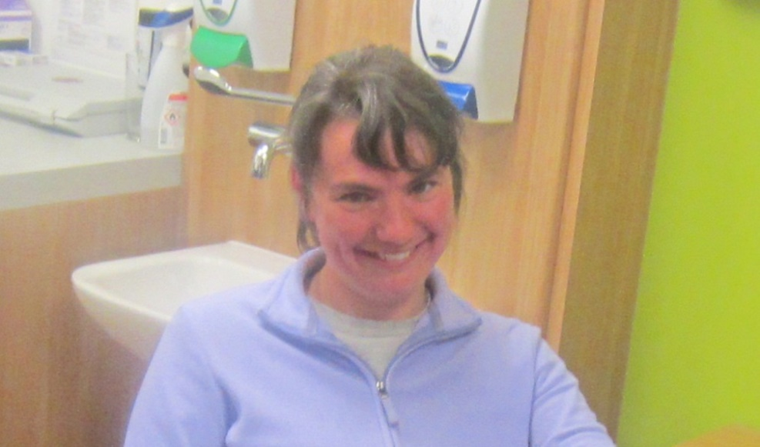This is Emma.

She lives with her friends and support staff at home. She has a health condition.

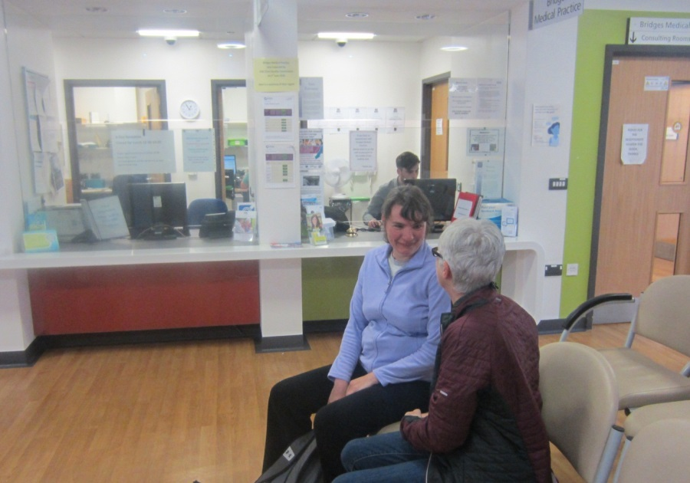As part of her yearly check-up Emma has two appointments at her doctor’s surgery.

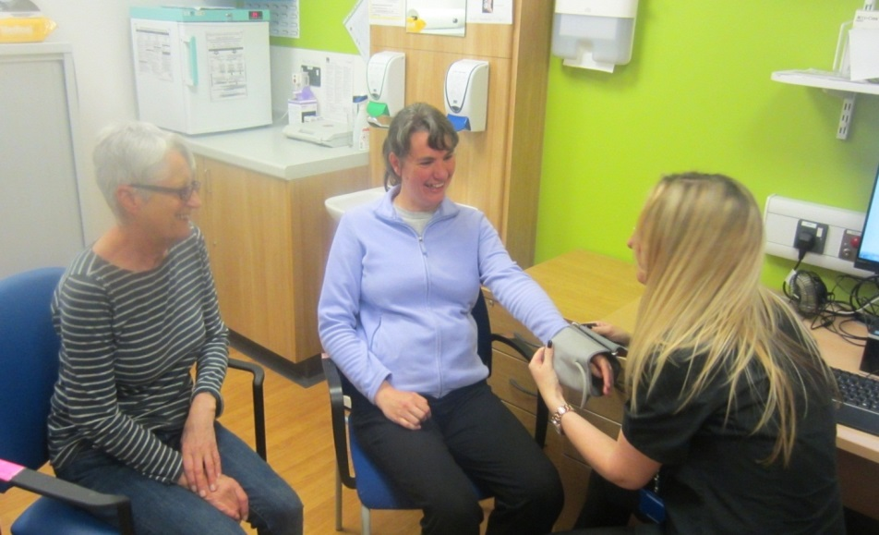Emma goes with Julie, a member of her support staff, to her first appointment.

Emma has tests that need to be done like blood tests, breathing tests and a blood pressure check.

Emma gets the results of these tests in the post.

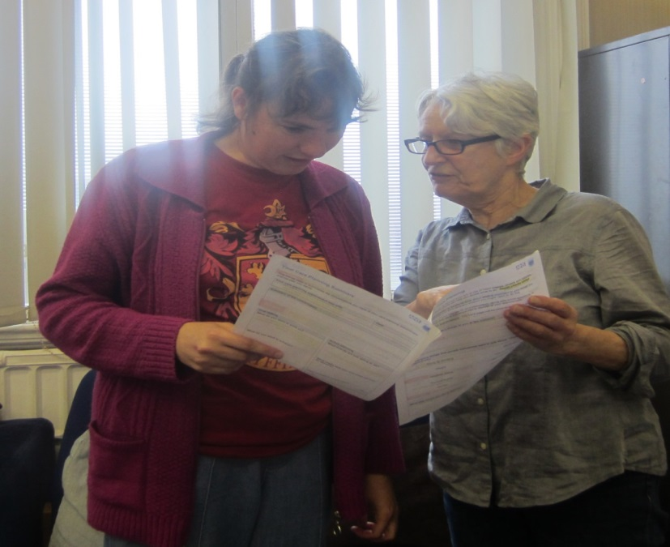Emma talks about her test results with Julie.

They plan what questions Emma will ask the doctor or nurse.

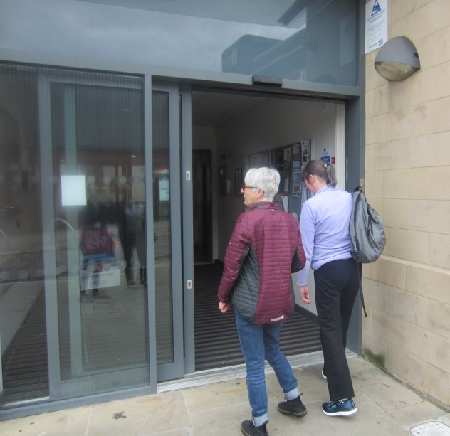One-week later Emma goes with Julie to the surgery for her second appointment and takes her results letter with her.

At the second appointment Emma and the nurse will talk about what is important to Emma.

At her appointment Emma and the nurse talk about

* What matters to her
* Her test results
* What help she might need

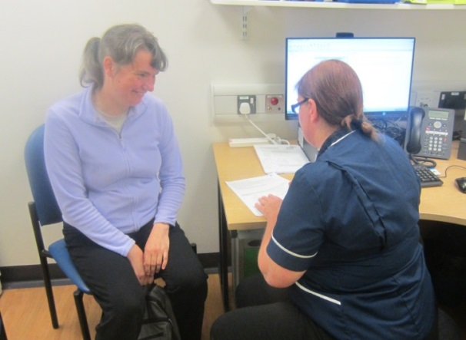Emma feels she has more say in her care. She knows what she needs to do to stay well.