


Looking after your future health
Name:
Your heart and stroke risk
Previous | Latest
  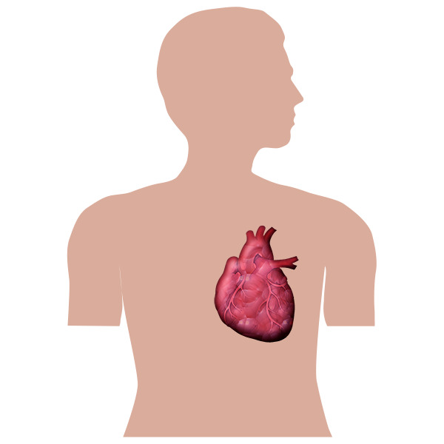 | There are tests that can work out your chances of having heart problems or a stroke.  It is better if this number is less than 10.
 | You can lower the risk by being more active.
 | You can lower the risk by stopping smoking.
 | You can lower the risk by eating healthy food and being a healthy weight.
Your ideas

Improving your future heath
Your weight
Previous | Latest
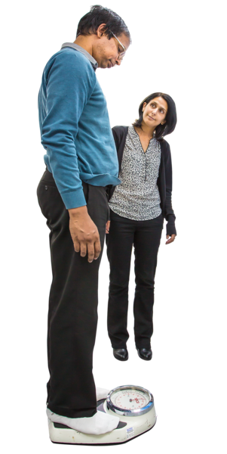 | Being overweight or underweight can cause health problems.
Your ideas
Smoking
 |  | Stopping smoking helps to keep you healthy..
Your ideas

Cholesterol (Fat in the blood)
Previous | Latest
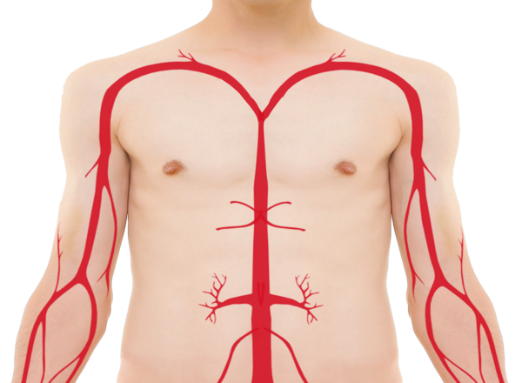   | Too much fat in blood (cholesterol) can lead to heart problems.  Keeping your total cholesterol less than 5 is better for your health. Your nurse can talk to you about ways to keep your cholesterol lower.
Your ideas
Check if you are at risk of developing diabetes: HbA1c
Previous | Latest
 | This blood test can check for diabetes.  A number over 42 means you might develop diabetes in the future.
Your ideas
Blood pressure
Previous | Latest
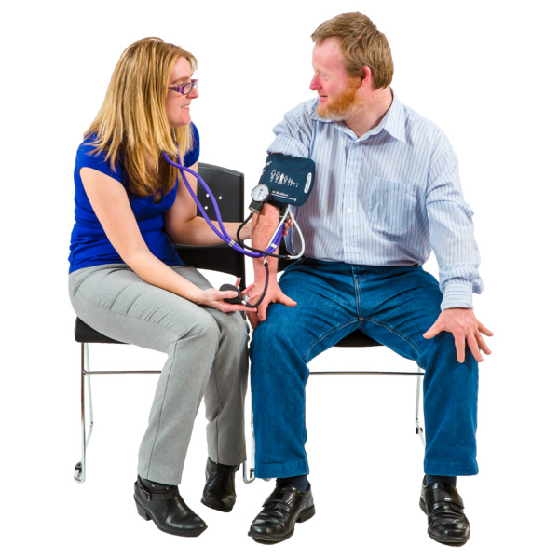 | Keeping your blood pressure below 140/90 helps keep your heart healthy.
Your ideas

