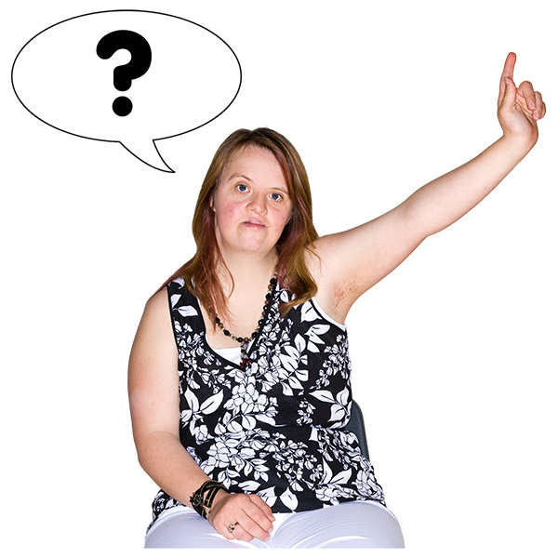

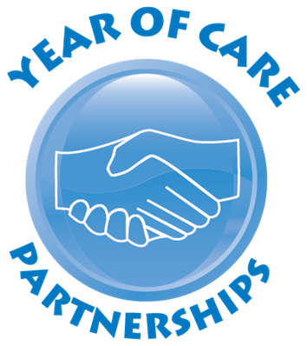
Looking after your heart health
Name:
Yor heart health
Weight
Previous | Latest
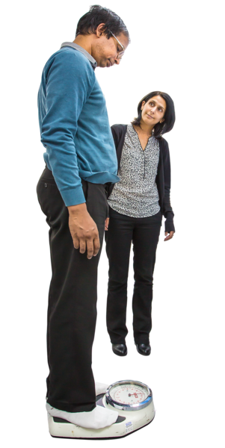 | Being a healthy weight is important. Being overweight or underweight can cause health problems.
Your ideas
Smoking
Current smoking status
 | Stopping smoking helps to keep you healthy.
Your ideas

Mood
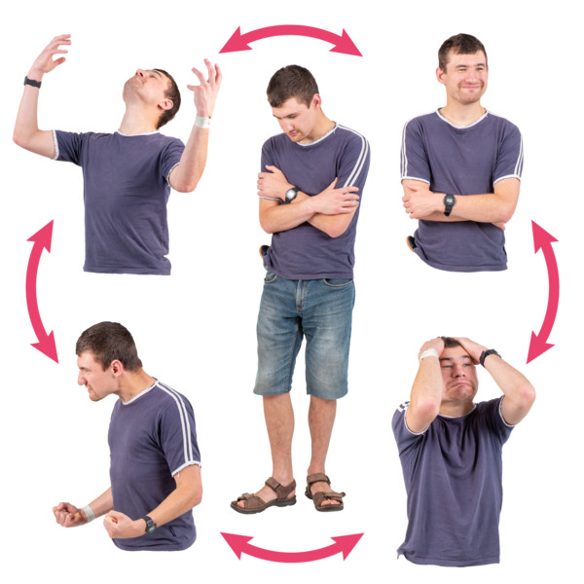 |  | How you feel can make a difference to your health.
Have you felt down or unhappy
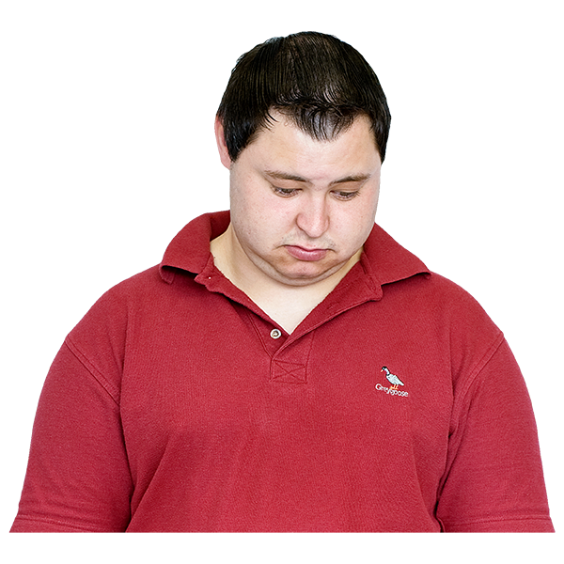
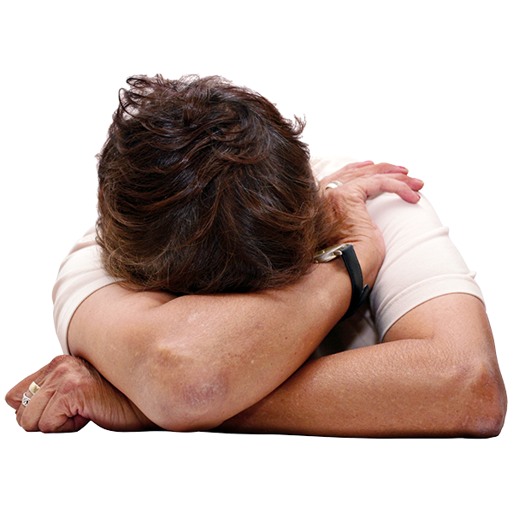
Heart checks
Blood pressure
Previous | Latest
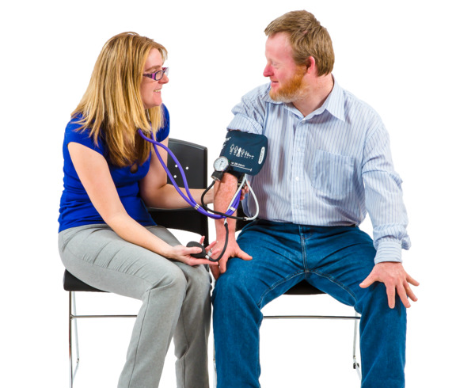 | Keeping your blood pressure below 140/90 helps keep you healthy.
Your ideas

Cholesterol non-HDL (Fat in the blood)
Previous | Latest
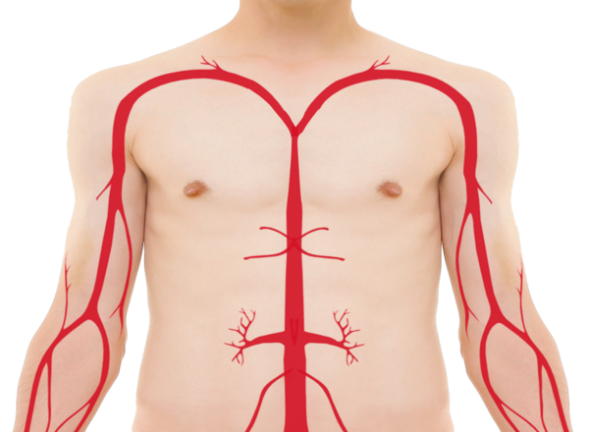  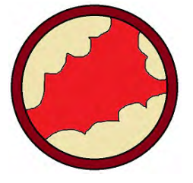 | Too much fat in blood can lead to heart problems (bad cholesterol).  Keeping your non-HDL cholesterol lower than 2.5 is better for your health. Your nurse can talk to you about ways to do this.
Your ideas
Heart test and checks
Kidney test: (eGFR)
Previous | Latest
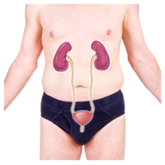  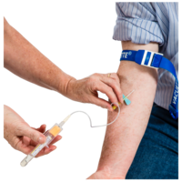 | Your kidneys are tested by a blood test to check they are working okay. This test should be more than 60.
Your ideas
Diabetes test: HbA1c (sugar in your blood)
Previous | Latest
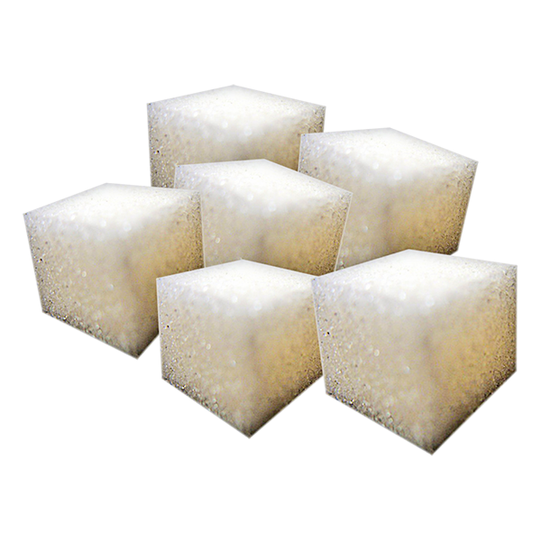 | Diabetes is more common in people with heart disease.
Your ideas
How does your heart problem affect you?
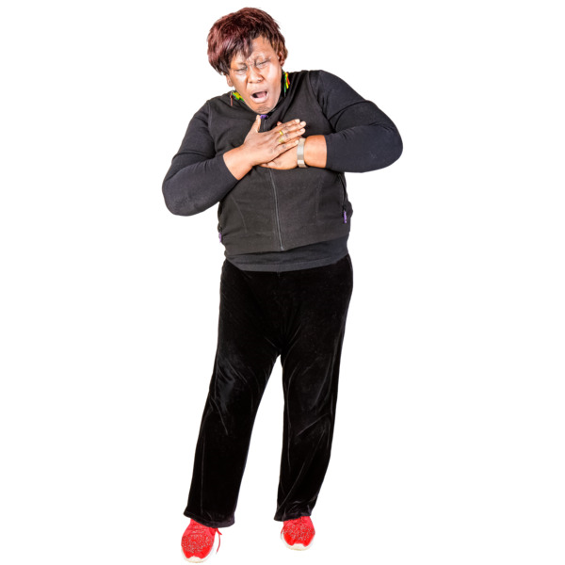 | Heart problems can cause pain in your chest and make you feel out of breath.  Do you have these?  Do they stop you doing everyday things?
Your ideas
Eyes
Date of last test
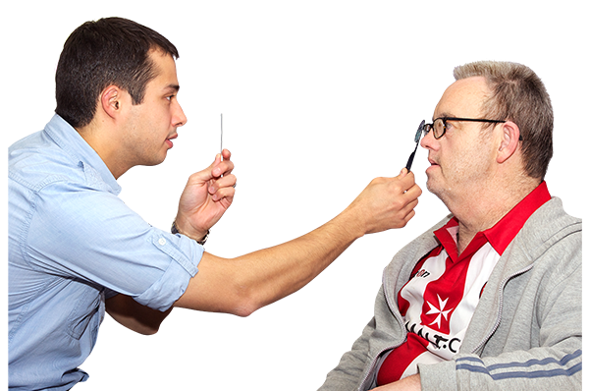 | You should have your eyes checked every few years. This check looks for any changes.  Are you worried about your eyes?

Feet
Date of last test
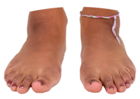 | Your yearly foot check looks for problems with blood flow (circulation) or the feeling (nerves) in your feet.  How are your feet?
Your ideas?

