


Looking after your diabetes
Name:
Looking after your diabetes
Weight
Previous | Latest
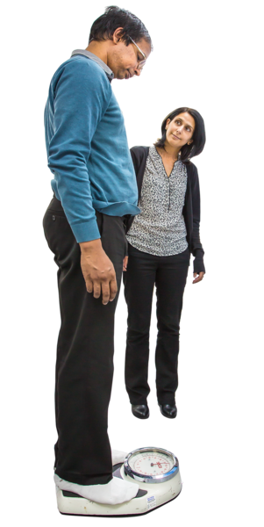 | Being a healthy weight is important. Being overweight or underweight can cause health problems.
Your ideas
Smoking
Current smoking status
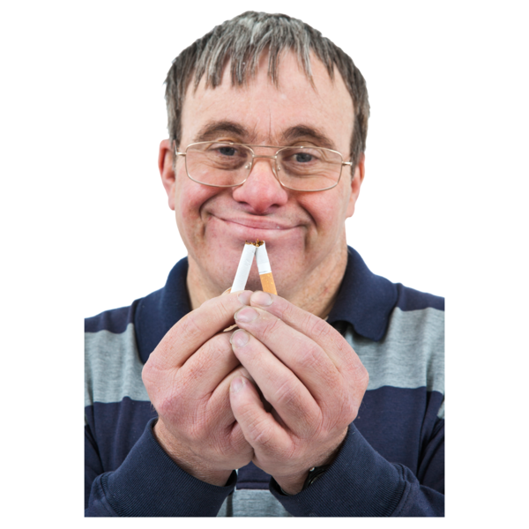 | Being a healthy weight is important. Being overweight or underweight can cause health problems.
Your ideas
Mood
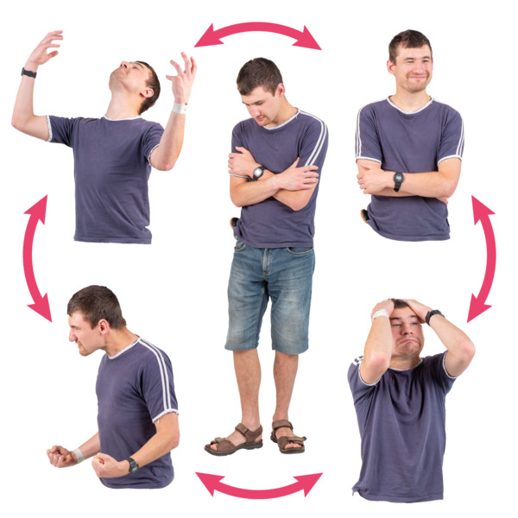 |  | How you feel can make a difference to your health.
Have you felt down or unhappy
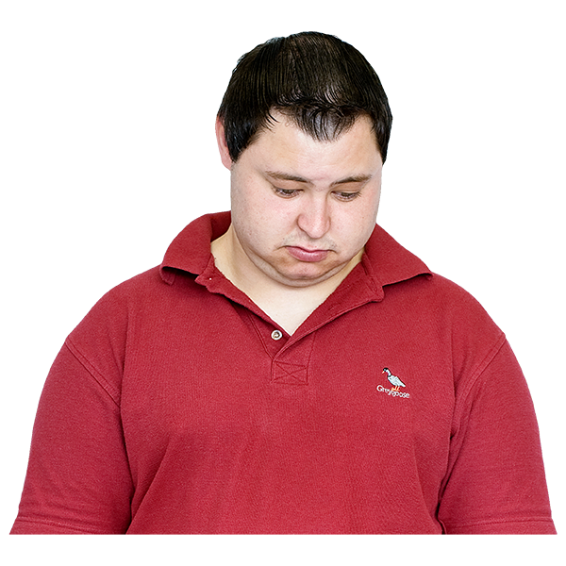

HbA1c (sugar in your blood)
Previous | Latest
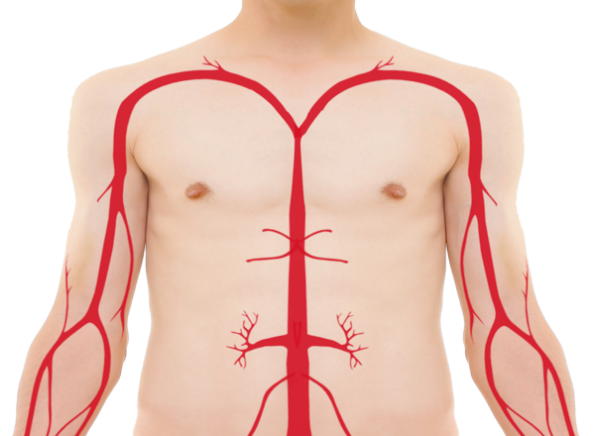  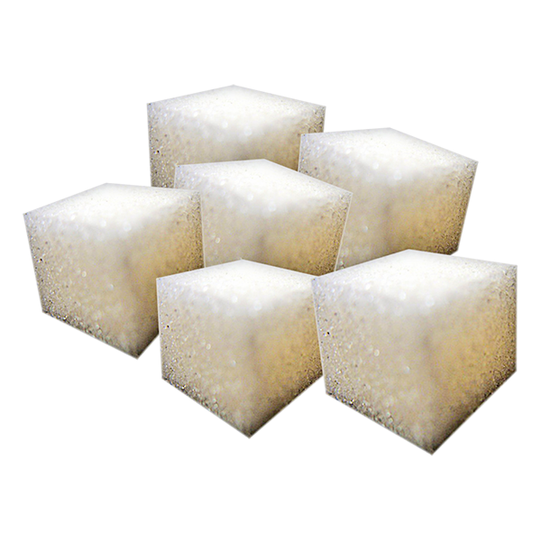 | HbA1c is check of the sugar levels in your blood.  The number should be less than 59 to stay healthy.
Your ideas

Cholesterol non-HDL (Fat in the blood)
Previous | Latest
 | Too much fat in blood can lead to heart problems (bad cholesterol).  Keeping your non-HDL cholesterol lower than 2.5 is better for your health. Your nurse can talk to you about ways to do this.
Your ideas
Blood pressure
Previous | Latest
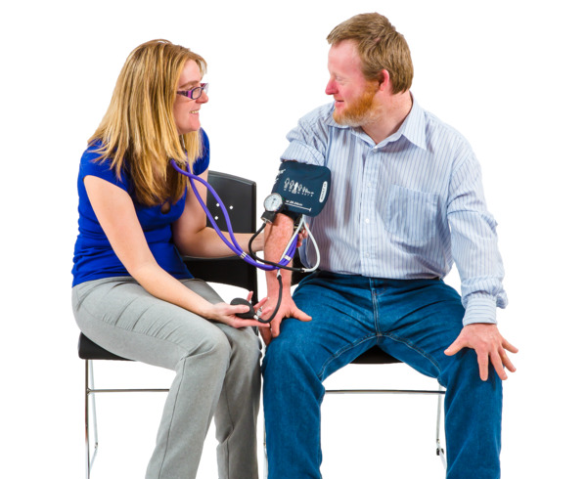 | Keeping blood pressure below 140/80 helps keep you healthy.
Your ideas
Kidney tests: your kidneys are tested by looking at two tests
Early morning urine test (ACR)
Previous | Latest
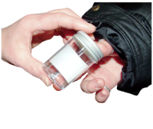 | Your kidneys are tested by a urine (wee) test. This number should be less than 3.  Your ideas?
Blood test (eGFR)
Previous | Latest
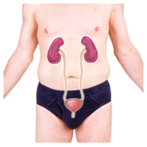  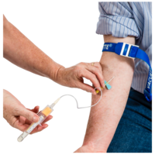 | Your kidneys are tested by a blood test. This result should be more than 60  Your ideas?
Eyes
Date of last test
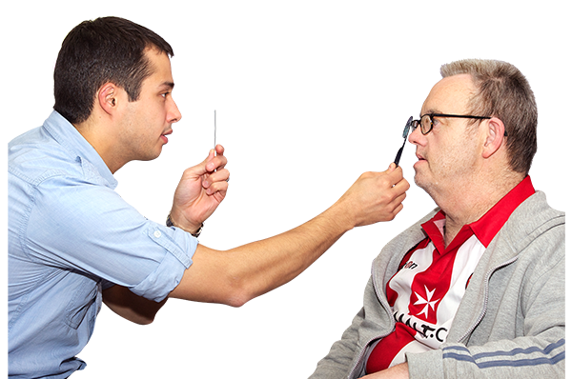 | You should have your eyes checked every few years. This check looks for any changes.  Are you worried about your eyes?

Feet
Date of last test
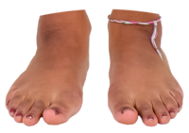 | Your yearly foot check looks for problems with blood flow (circulation) or the feeling (nerves) in your feet.  How are your feet?
Your ideas?

