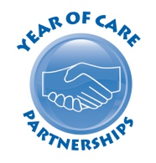

The Very Person Centred Medical Group
Self-Care Place
Welltown

Date XXXXX

Dear XXX

Our practice is currently trying to identify if people may benefit from support or advice on how to stay well at home.

Every year we will be in touch to see how you are doing.

If you could please complete the enclosed form to tell us which description you feel fits you best this will help us to understand how you’re doing.

If you need help to complete this form please let us know.

Please post this form back to the surgery using the enclosed pre-paid envelope.
OR
We will contact you by telephone to discuss this further.
(Note to practice - please delete the statement that does not apply)

Your GP

Enclosed:
Self-assessment tool
Pre-paid envelope

