**Options for recording the care plan**

The options for recording the care plan depend to some extent on the clinical systems used in a practice. The options are to:

1. Record the key elements of discussion and the goal and actions agreed within the consultation notes as per many other appointments
2. Use an electronic word document as a template to populate the care plan which can be printed off and given to the patient – attach it to the relevant consultation
3. Use a care and support planning document in the consultation and scan it in and attach it to the consultation
4. Use an electronic template (see screen shots below as examples of how templates could be designed; for practices using Ardens SystmOne and EMIS Web templates are available)

**SystmOne**

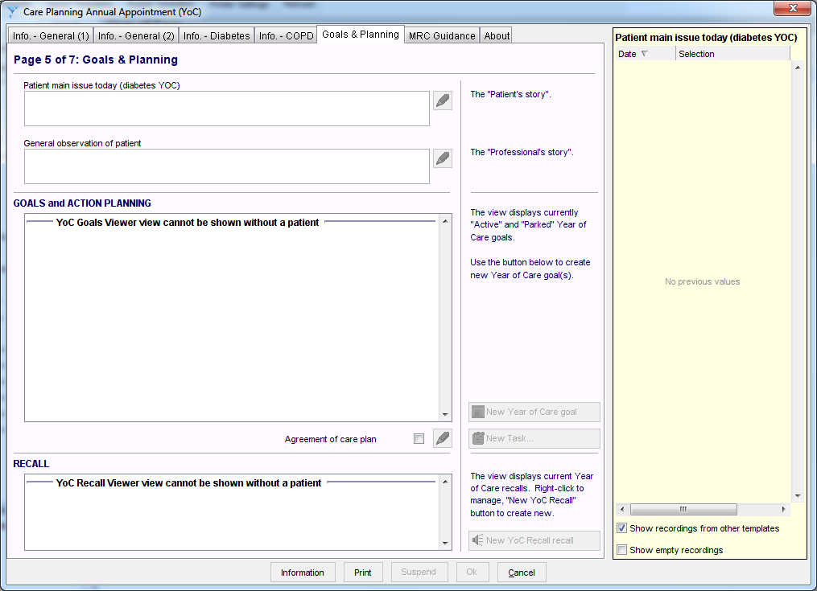

**EMIS**

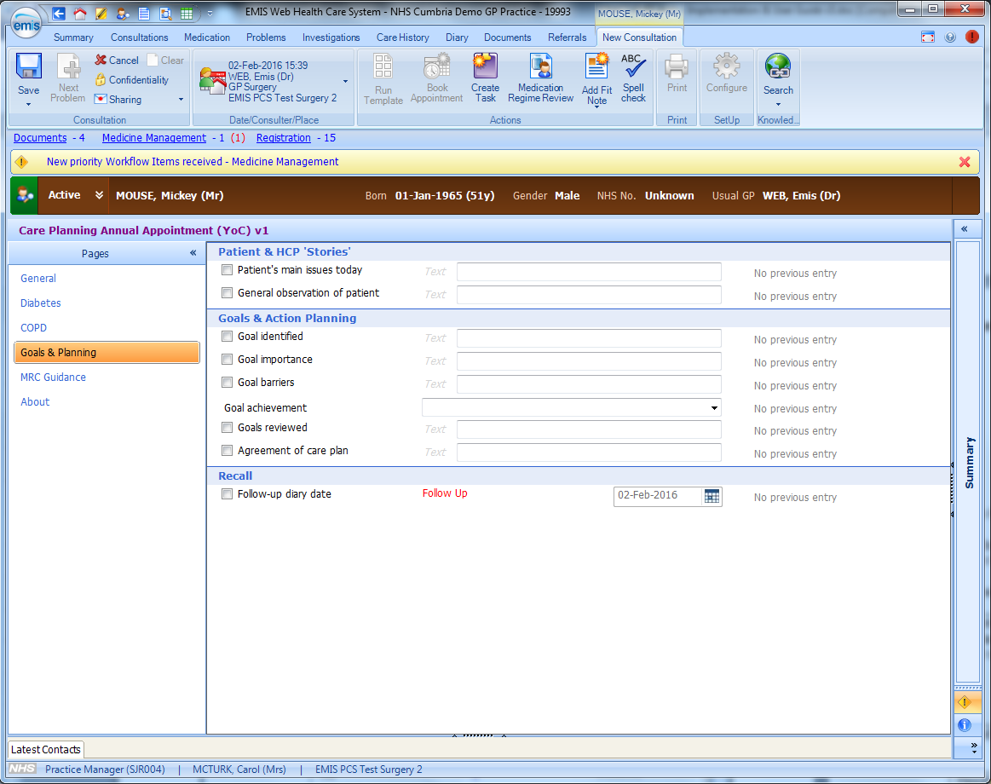

## What does the patient’s care plan look like?

What the patient needs to take away on their care plan and what you need in the clinical record will not necessarily be the same. If you consider the stages of a personalised care and support planning conversation the clinical record needs to detail the discussion and the different perspectives of both the patient and the practitioner, as well as the care plan.

The care plan that the patient receives will focus on the outcome of the discussion including the goals and actions agreed by both the patient and the health care professional.

See the document ‘Your care and support planning summary’. This should be the last page of the preparation prompt the patient receives after their information gathering appointment and before the PCSP conversation.

## SNOMED codes for PCSP

There are two SNOMED-CT codes for personalised care and support planning (PCSP)

* 1187911000000105 Personalised care and support plan agreed (finding) - the number of personalised care and support plans agreed in the reporting period.
* 1187921000000104 Review of personalised care and support plan (procedure) - the number of patients who have received a review of their personalised care and support plan in the reporting period.